Directory

1. Overview 3
   1. Introduction 3
   2. function 3
   3. Application 3
2. Programme description 4
   1. Parameter said Ming 4
   2. Pin said Ming 5
3. Serial communication Agreement 6
   1. Communication grid Type 6
   2. Communication means Order 7
      1. Control System directive 7
      2. Check Enquiry Order 8
   3. Number of chips returned According to 9
      1. The number of electricity returned on the chip According to 9
      2. Track Playback complete return The data
      3. Number returned by Chip answer According to ten
      4. Number of errors returned by the chip According to one
      5. Device Insert Pull out News
   4. Serial control command Detailed
      1. Specify song playback instructions [ can refer directly to 3.4.7]12
      2. Specify volume playback Command
      3. Single Loop playback Directive
      4. Specify multicast Put equipment
      5. Specify folder file name Play
      6. Specifies that the folder starts to follow Ring Play
      7. Set the current track to a loop Play
      8. Open and close Dac

3.4.9 combined playback function Instructions [ only for FLASH] .... ..... ..... ..... ..... ..... ...... ..... ...... ..... ..... ...... ...... ... **Error! No bookmarks are defined.**

3.4.10 The point with the volume parameter Make play

* 1. Serial Query command Detailed info
     1. Query the current online setting Preparation
     2. Play Status Query Directive
     3. Specify the total folder track Number of queries
     4. The total number of folders in the current device Search

1. Reference circuit

1

* 1. Serial connection Kou
  2. Key to connect Kou
  3. External single channel work Put
  4. The tone of the user to adjust the amplifier Volume
  5. Usb Update Voice Description
  6. User uses a blank FLASH Description

4.6 reference routines for grouped playback .................................................................................... **Error! No bookmarks are defined.**

##### Attention Item

* 1. GPIO 's Special Sex
  2. Attention in the application Dot
  3. Serial Port Gymnastics For
     1. Serial Port Gymnastics As a process
     2. Serial port programming reference to say Ming
     3. The serial port programming needs the proper delay attention Dot
     4. Verification of the important saying Ming
     5. MCU of Crystal Oscillator Select

##### Disclaimer

##### Reference Routines

##### Pc End Serial port Debugging instructions For example

* 1. Control means Order
  2. Query parameters Number command

# Overview

## Brief introduction

#### Yx5300-24ss is a voice chip to provide a serial port, perfect integration of the MP3 , WAV The hard decoding. At the same time, the software supports industrial-level serial communication protocol to Spiflash , TF Card or U Disk as a storage medium, the user can flexibly choose any one of the devices as the voice of the storage media. Through a simple serial port command to complete the playback of the specified voice, and how to play voice functions, no need for cumbersome low-level operation, easy to use, stable and reliable is the biggest feature of this product.

No need for any burner, no software, USB Direct Burn Write FLASH .

## Function

1 , support sampling rate (KHz): 8/11.025/12/16/22.05/24/32/44.1/48

2 , 24 Bit Dac Output, dynamic range support 90dB , signal to noise ratio support 85dB

3 , maximum support 16M bytes of Spiflash . For example W25q16[2m byte ] , w25q128[16m byte ]

4 , a variety of control modes, and port control mode, serial port mode, AD Key control mode

5 , miniUSB interface to update the voice file without installing any software. Support Xp And WIN7 System.

6 , support the combination playback function, can realize the timekeeping, the report temperature, to a certain extent can replace some expensive Tts Scheme

7 , 30 the level of the volume can be adjusted, 5 Level EQ can be adjusted [ This feature is temporarily closed ]

8 , self-belt 3W amplifier, the direct external speaker can complete the playback

9 , support 8 the trigger playback of the segment speech, IO Detection of the way, so suitable for carbon film buttons and so on occasions

Ten , can also support U disk, TF Card and Spiflash As storage media

## Application

1 , car navigation voice broadcast

2 , Highway transportation inspection, toll station voice prompts;

3 , train station, bus station security check voice prompts;

4 , electric power, communication, financial business Hall voice prompts;

5 , the vehicle enters and exits the channel to verify the voice prompt;

6 , the police border inspection channel voice prompts;

8 , electric sightseeing car safe travel voice notice;

9 , mechanical and electrical equipment fault automatic alarm;

Ten , fire-fighting voice alarm prompts;

One , automatic broadcast equipment, regular broadcast

# Programme description



The chip is chosen Soc Scheme, which integrates a 16 Bit of MCU , and a specially designed for audio decoding ADSP , the method of hard decoding is used to guarantee the stability and sound quality of the system. Small package sizes are more responsive to the need for embedding other products

## Parameter description

|  |  |
| --- | --- |
| **Name** | **Parameters** |
| MP3 file format | 1, support all bit rate 11172-3 and iso13813-3 Layer3 audio decoding |
| 2, sample rate Support (KHZ): 8/11.025/12/16/22.05/24/32/44.1/48 |
| 3, Support Normal, Jazz, Classic, Pop, rock and other sound effects |
| USB interface | 2.0 Standard |
| UART interface | Standard serial port, TTL level, baud rate can be set [user can not be set] |
| Input voltage | 3.3v-5v[7805 a diode is the best for the rear cascade |
| Rated current | 10ma[Static] |
| Low Power current | <200ua |
| Power | Drive headphones, Amplifier |
| Size | SSOP24 [Unit: MM] |
| Operating temperature | -40 degrees-80 degrees |
| Humidity | 5% ~ 95% |
| Main chip model | YX5300-24SS [SSOP24] |

## Pin description

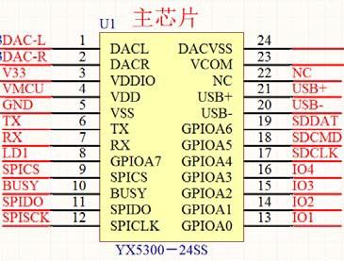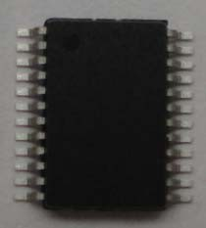

|  |  |  |  |
| --- | --- | --- | --- |
| Pin serial Number | Pin Name | Function description | Note |
| 1 | Dacl | Audio output left channel | Drive headphones, Amplifier |
| 2 | Dacr | Audio output Right Channel | Drive headphones, Amplifier |
| 3 | Vddio | 3.3V Power output | Power to SPI Flsah |
| 4 | Vdd | 5V Power Input | Can not exceed 5.2V |
| 5 | Vss | Power to |  |
| 6 | TX | UART Serial Data output | TTL level of 3.3V |
| 7 | Rx | UART Serial Data input | TTL level of 3.3V |
| 8 | GDPIA7 | Play indicator | Recommended to connect the transistor driver |
| 9 | Spics | Spi_cs Slice Select bus |  |
| 10 | BUSY | Busy output | Low level output when playing |
| 11 | Spido | SPI_DO Data Bus |  |
| 12 | Spiclk | SPI_CLK Data Bus |  |
| 13 | GPIOA1 | P01 | Triggering the output of the outlet 1 |
| 14 | GPIOA2 | P02 | Triggering the output of the outlet 2 |
| 15 | GPIOA3 | P03 | Triggering the output of the outlet 3 |
| 16 | GPIOA4 | P04 | Triggering the output of the outlet 4 |
| 17 | GPIOB5 | SD_CLK Clock Bus | Connect a TF card or an SD card |
| 18 | GPIOB6 | Sd_cmd Command Bus | Connect a TF card or an SD card |
| 19 | GPIOB7 | Sd_dat Data Bus | Connect a TF card or an SD card |
| 20 | usb- | Usb-dm | USB Port of Computer |
| 21 | usb+ | usb+ DP | USB Port of Computer |
| 22 | NC | NC |  |
| 23 | Vcom | Decoupling |  |
| 24 | Dacvss | To |  |

1. **Serial Communication Protocol**

Serial port as a common communication in the field of control, we carried out the industrial level of optimization, the addition of the frame of the calibration, restart, error handling measures, greatly enhance the stability and reliability of communications, while on this basis to expand a more powerful RS485 For networking functions, the communication baud rate of the serial port can be set by default 9600

## Communication Format

#### Support asynchronous serial communication mode, through the serial port to receive the command of the host computer Communication standard: 9600 bps

Data Bit: 1

Check Bit: none flow control System: None

|  |  |  |
| --- | --- | --- |
| **Format** **: $S** **VER** **Feedback** **Para1** **Checksum$o** | | |
|  |  |  |
| $S | Start bit 0x7e | Each command feedback starts with $, i.e. 0x7e |
| VER | Version | Version information |
| Len | Number of bytes after Len | Checksum not counted |
| Cmd | Command word | Represents a specific action, such as play/pause, etc. |
| Feedback | Command Feedback | Do you need feedback, 1 feedback, 0 no feedback |
| Dat | Parameters | Associated with the front Len, no limit on length |
| Checksum | checksums [up to two bytes] | Cumulative and checksum [excluding starting bit $] |
| $O | End bit | End Bit 0xEF |
|  |  |  |

For example, if we specify a playback Spiflash , you need to send : 7E FF DD EF

Data length is 6, it 6 bytes are [FF 06 09 00 00 04] 。 Start, end, and checksum are not evaluated. The resulting results are then added and then used 0 minus, namely " 0-checksum= verify the data. If you do not understand this, you can refer to our "Debugging Manual". In addition, users can also directly ignore the checksum, reference to our 5.3.4 Chapter description.

## Communication instructions

Our newsletter is divided into the following two chunks

* Control instructions
* Query the parameters and status of the chip

### Control instructions

##### Here is how the control chip works

|  |  |  |
| --- | --- | --- |
| CMD command | The corresponding function | Parameters (16-bit) |
| 0x01 | Next song |  |
| 0x02 | A song. |  |
| 0x03 | Specified track (NUM) | 1-255 |
| 0x04 | Volume + |  |
| 0x05 | Volume |  |
| 0x06 | Specify volume | 0-30 |
| 0x07 | Keep | Keep |
| 0x08 | Single loop specify track playback | Refer to 3.4.3 |
| 0x09 | Specify Playback Device | Refer to 3.4.4 |
| 0x0A | Go to sleep--low power consumption | Power consumption 10MA |
| 0x0B | Wake Up Sleep |  |
| 0x0C | Chip Reset |  |
| 0x0D | Play |  |
| 0x0E | Time out |  |
| 0x0F | Specify folder file name playback | Refer to 3.4.5 |
| 0x16 | Stop it |  |
| 0x17 | FLASH storage device only [TF card and U disk not supported] | See 3.4.7 for details |
| 0x18 | Keep | Keep |
| 0x19 | Set the currently playing track to loop play | Refer to 3.4.8 |
| 0x21 | Turn on and off the DAC output of the chip | Refer to 3.4.9 |
| 0x22 | Group Playback | Refer to 3.4.10 |

* + 1. **Query directives**

**Here is the status of the query chip and related parameters**

|  |  |  |
| --- | --- | --- |
| CMD command Detailed (query) | The corresponding function | Parameters (16-bit) |
| 0x3C | Keep |  |
| 0x3D | Keep |  |
| 0x3E | Keep |  |
| 0x3F | Send initialization parameters | 0x1F (low 5 bits per person represents a folder) |
| 0x40 | return error, request to be sent again |  |
| 0x41 | Response |  |
| 0x42 | Query Current state | Refer to 3.4.10 |
| 0x43 | Query Current Volume |  |
| 0x44 | Query Current EQ | Keep |
| 0x45 | Keep | This version retains this feature |
| 0x46 | Keep | This version retains this feature |
| 0x47 | Total number of query Udisk files | Total number of files for the device |
| 0x48 | Query the total number of TF files | Total number of files for the device |
| 0x49 | Total number of files queried for FLASH | Total number of files in 5 folders |
| 0x4B | Querying the current track of Udisk | Physical order |
| 0x4C | Querying the current track of TF | Physical order |
| 0x4D | Query the current track of FLASH | Return folder number and track pointer |
| 0x4E | Query the track of a specified folder  Total | Refer to 3.5.2 |
| 0x4F | Querying the total file for the current device  Number of Clips | Refer to 3.5.3 |
| 0x61 | Querying the current folder pointer | FLASH only supported |

* 1. **The data returned by the chip**

The chip will have data returned in key places. For the user to control the working status of the chip

* Data on the success of electrical initialization on the chip
* The chip has finished playing the current track data
* The chip successfully received the instruction returned by the ACK ( answer )
* chip receives a frame data error [ including data confiscation integrity, checksum error two cases ]
* When the chip is busy, there is data coming, the chip will return the busy instruction
* U disk, TF Card Insert pull out, all data returned

### The data returned by the power on the chip

(1) , chip on the electricity, need a certain amount of time to initialize, this time is required according to Tf Card, U disk, Spiflash How much of the device's file is decided, generally in less than 500ms This time. If the initialization data for this time module has not been sent out to indicate an error in module initialization, please check the hardware connection

(2) , module initialization returned data is the current valid folder , such as return 7E FF modified 3F xx xx EF

==> which 0x03 is representative of U Disk and Tf The two devices are online

|  |  |  |
| --- | --- | --- |
| U Disk--Online | 7E FF + 3F xx xx EF | The relationship between the equipment is or |
| TF--Online | 7E FF 3F xx xx EF |  |
| PC--Online | 7E FF 3F xx xx EF |  |
| FLASH--Online | 7E FF 3F/xx xx EF |  |
| U disk, TF--online | 7E FF modified 3F xx xx EF |  |

(3) , MCU You must wait for the chip initialization command to send the corresponding control instructions, otherwise sent instructions chip will not be processed. It will also affect the normal initialization of the chip.

### The data returned by the track playback finished

|  |  |  |
| --- | --- | --- |
| U disk play the 1th song | 7E FF + 3C xx xx EF | U disk play the 1th song finished |
| U disk play the 2nd song | 7E FF 3C xx xx EF | U disk play the 2nd song finished |
| TF Card finished playing the 1th song | 7E FF + 3D xx xx EF | TF Card plays the 1th tune finished |
| TF Card finished playing the 2nd song | 7E FF 3D xx xx EF | TF Card plays the 2nd tune finished |
| FLASH Play the 1th song | 7E FF modified 3E xx xx EF | FOLDER1 's 1th song is played out. |
| FLASH play the 2nd song | 7E FF 3E/xx xx EF | FOLDER2 's 2nd song is played out. |

1 , for a lot of trigger-type playback requirements, our chip correction to play a song automatically into the Stop state. If the user needs this type of application. You only need to specify the track playback. This way, the track will automatically stop when it is played, waiting for instructions

2 , in addition we specialize in opening up a Io As a status indicator for decoding and pausing. Please see section 5 Feet

(1) , playback state output Low level [ many amplifiers have mute feet that can be used by this Io Direct Control ] (2) , playback suspend state, output high level. Chip sleep state. Also low level

3, after the chip power, the initialization of normal, the chip will automatically enter the device playback status. And stop decoding, waiting for the user to send the relevant instructions to play

4, another user after the specified device, the need to wait for 200ms time, and then send the specified track, because once the track is specified, the system will be the specified device for the initialization of the file system, if immediately send the specified track command, will cause the chip can not receive.

### Chip answer the returned data

|  |  |  |  |  |  |  |  |  |  |  |  |  |
| --- | --- | --- | --- | --- | --- | --- | --- | --- | --- | --- | --- | --- |
| Chip return | Ack | 7E | Ff | 06 | 41 | 00 | 00 | 00 | Xx | Xx | Ef | Description of successfully receiving data |

(1) , in order to enhance the stability between data communication, we increase the response processing, ackb The byte is the setting of whether a reply response is required. The advantage of this is to ensure that each communication has a handshake signal, the answer will indicate MCU The data sent, the chip has been successfully received, immediately processed.

(2) , for the general application, the customer is free to choose, do not add this response processing is also possible.

### The data returned by the chip error

|  |  |  |
| --- | --- | --- |
| Return busy | 7E FF EF XX | When the chip is initialized in the file system |
| Currently in sleep mode | 7E FF/xx EF | Sleep mode only supports specified devices |
| Serial Port receive error | 7E FF x xx EF | The serial port one frame data did not receive completes |
| Checksum error | 7E FF/xx EF | and checksum error |
| Specify file scope | 7E FF-XX EF | The designation of the file exceeds the set range |
| The specified file was not found | 7E FF for xx xx EF | Specifies that the file is not found |
| Data does not conform to rules | 7E FF-XX EF | If the minimum is 1, send a 0 |

(1) , in order to enhance the stability between data communication, we have added the error handling mechanism. The chip receives the data which does not conform to the format, will have the information feedback

(2) , the customer is strongly advised to handle this command when the environment is relatively bad. If the application environment is general, you can not handle. (3) , the chip return busy, basically is the chip on the electrical initialization time will return, because the chip needs to initialize the file system

(4) , after the chip on the power, into the equipment state, equipment is Spiflash . If Spiflash If you are not online, you will automatically go to sleep.

(5) , just refer to the tests we have given Sdk program, the porting inside the serial operation part, there will be no checksum error, where we strongly recommend the user to use our method of calibration. Because no one can guarantee that the data transmission will not be wrong.

(6) , file specified section error, please refer to the following detailed

### Device Insert Pull out message

|  |  |  |
| --- | --- | --- |
| U disk Insert | 7E FF 3 a xx xx EF |  |
| TF Insert | 7E FF 3 x xx EF |  |
| PC Insert | 7E FF 3 xx xx EF |  |
| U disk Pull out | 7E FF + 3B xx xx EF |  |
| TF Pull Out | 7E FF 3B xx xx EF |  |
| PC Pull-out | 7E FF 3B xx xx EF |  |

(1) , in order to enhance the flexibility of the chip, we particularly increased the device insertion, pull-out instructions feedback. It is convenient for users to know the working status of Chips.

(2) , when the device is plugged in, we go to the device wait state by default, if the user inserts a lamp with U Disk, you can see U

The disc light flashes. You can also receive serial messages that are plugged in by the device.

## Serial Port Control Instruction detailed

The following is a detailed description of the key areas -- for control Directives :

* Specify track Playback
* Specify the volume to play
* Specify which devices to play
* Full Loop playback Instructions
* Combined playback function [ highlights ]
* Play with the specified track with volume parameters

### Specify song playback instructions [ can refer directly to 3.4.7]

We give the instruction to support the specified track playback, the song selection range of 0~255. actually can support more, because involves the file management reason, supports too many songs, can cause the system to operate slowly, the general application also does not need to support so many files. If the customer has an unconventional application, please communicate with us beforehand.

(1) , such as selecting the first song to play, the sending part of the serial port 7E ff E6 EF 7E--- Start command

FF--- Version information

--- Data Length ( does not contain checksums )

--- On behalf of the product number

--- Whether you need to answer [0x01: need to answer, 0x00: No need to return answer ]

1. --- high byte of track [DH]
2. --- low byte of track [DL], It represents the first song to play FF--- High-byte checksum

E6--- Low-byte checksum

EF--- End command

(2) , for selections, if you choose the first 100 First, will 100 Converted to 16 into the system , default is Double byte , Just for 0x0064 . DH = 0x00 Dl = 0x64

(3) , other operations, and so on, because the embedded domain uses 16 The system is one of the most convenient operations.

### Specify volume playback Instructions

(1) , our system on the default volume of power is 30 level, if you want to set the volume , send the appropriate instructions directly

(2) , such as specifying that the volume is 15 -Level , command sent by serial port : 7E FF 0F ff D5 EF

(3) , DH = 0x00; DL = 0x0f , 15 Converted to 16 In the system 0x000f . You can refer to the description of the playlist section

### Single Loop playback instructions

|  |  |  |  |  |  |  |  |  |  |  |  |
| --- | --- | --- | --- | --- | --- | --- | --- | --- | --- | --- | --- |
| Loop through the specified track | 7E | Ff | 06 | 08 | 00 | 00 | 01 | Xx | Xx | Ef | Loop play the first song |
|  | 7E | Ff | 06 | 08 | 00 | 00 | 02 | Xx | Xx | Ef | Loop the second song |
|  | 7E | Ff | 06 | 08 | 00 | 01 | 01 | Xx | Xx | Ef | Loop play the 1th Song of FOLDER1 |

(1) , for some of the requirements of single loop playback, we have improved this control command 0x08 . In the operation Tf Card or U Disk is specified in the physical order in which the file is stored, and this is a matter for the user's attention. But in the operation FLASH , refer to the test instructions above, as specified in the folder partition.

(2) , in the loop playback process, you can play the normal operation / pause, Previous, next, volume adjustment, including EQ and so on and the state is still loop play . you can turn off loop playback by specifying single to trigger playback or stop

### Specify Playback Device

(1) , our chip default is to support 4 types of playback devices , only Equipment online can specify the device to play the device is online, our software will automatically detect, no user relationship.

(4) , look at the table, select the appropriate instructions to send

(3)、指定设备之后。芯片会自动进入停止解码状态，等待用户指定曲目播放。从接收到指定设备到芯片内部完成初始化文件系统。大概需要 200ms。请等待 200ms 之后再发送指定曲目的指令。

|  |  |  |
| --- | --- | --- |
| Specify playback Device-u disk | 7E FF-xx-XX EF | XX xx: On behalf of the verification |
| Specify Playback device-TF card | 7E FF the EF xx |  |
| Specify Playback device-pc | 7E FF + xx EF |  |
| Specify Playback device-flash | 7E FF MB XX EF |  |
| Specify Playback device-sleep | 7E FF x xx EF |  |

### Specify folder file name playback

|  |  |  |
| --- | --- | --- |
| **001xxx.mp3 of Folder 01** | 7E FF modified 0F xx xx EF | TF Card or U disk |
| **100xxx.mp3 of Folder 11** | 7E FF 0F 0B xx xx EF | TF Card or U disk |
| **255xxx.mp3 of Folder 99** | 7E FF 0F/FF xx xx EF | TF Card or U disk |
| **The 1th Song of FOLDER1** | 7E FF modified 0F xx xx EF | [FLASH] |
| **The 1th Song of FOLDER2** | 7E FF modified 0F xx xx EF | [FLASH] |

(1) , the specified folder playback is the extended feature we developed, the default folder is named by " a", "one" In this way, for the stability of the system and the speed of song switching, the default maximum support per folder 255 Song , Maximum Support 99 A folder

(2) , such as specifying "a" folder's 100xxx. MP3 file , the command sent by the serial port is : 7E FF 0F x xx EF

DH: represents the name of the folder , Default Support 99 a file , that 01--99 The naming

DL: it represents the tracks. , default up to 255 Song, namely 0x01 ~ 0xFF

(3) , for the standard of the chip, you must specify both the folder and file name to lock a file. It is also possible to specify a folder individually or to specify a file name separately, but the management of the file will become worse. The specified folder and the specified track are supported MP3 , WAV (4) , the following two diagrams illustrate folder and file name designation [ about two drawings ]

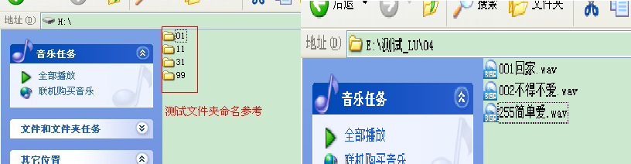

(5) , Spiflash Maximum Support 5 A FOLDER , please do not exceed this range when the user operates.

### Specifies that the folder starts looping

|  |  |  |  |  |  |  |  |  |  |  |  |
| --- | --- | --- | --- | --- | --- | --- | --- | --- | --- | --- | --- |
| **Specify a folder loop to play** | 7E | Ff | 06 | 17 | 00 | 00 | 02 | FE | E2 | Ef | Specify 02 folder loop playback |
|  | 7E | Ff | 06 | 17 | 00 | 00 | 01 | FE | E3 | Ef | Specify 01 folder loop playback |
| **Specify that FOLDER loops play** | 7E | Ff | 06 | 17 | 00 | 03 | 01 | Xx | Xx | Ef | FOLDER3 's 1th loop playback |

(1) , for Tf Card and U disk, the name of the folder must be " --- " . Can not exceed 99

(2) , for Spiflash , the user can 5 Any loop of a folder, refer to the reference instructions above.

03 The specified folder is FOLDER3

01 Specifies that the first song of the folder starts, if this is the . Then from the first 2 The song starts looping through this folder

(3) , the user can send a stop command to end the loop playback.

### Set the current track to loop play

|  |  |  |  |  |  |  |  |  |  |  |  |
| --- | --- | --- | --- | --- | --- | --- | --- | --- | --- | --- | --- |
| **Loop playback Turn off** | 7E | Ff | 06 | 19 | 00 | 00 | 00 | FE | E2 | Ef | Single Loop playback Open |
|  | 7E | Ff | 06 | 19 | 00 | 00 | 01 | FE | E1 | Ef | Single Loop playback off |

(1) , and sends this instruction during playback, looping through the current track. If the current processing is paused or stopped, the chip will not respond to this directive

(2) , if you want to turn off the single loop playback, send off the instructions can be, so that the current track played after the completion of the stop.

### Open and close Dac

|  |  |  |  |  |  |  |  |  |  |  |  |  |
| --- | --- | --- | --- | --- | --- | --- | --- | --- | --- | --- | --- | --- |
| **Set up**  **Dac** | 7E | Ff | 06 | 1 A | 00 | 00 | 00 | FE | E1 | Ef | Open | Dac |
|  | 7E | Ff | 06 | 1 A | 00 | 00 | 01 | FE | E0 | Ef | Off | dac[High Resistance] |

(1) , in some users need to overlay their own sound source of the occasion, you can pause the current playback of the voice, and then we chip Dac The output is set to high resistance so that users can share a power amplifier to play their own sound source, but Dac The opening and closing, there will be a sound Po Voice, please the attention of the user friends.

(2) , chips can be closed at any time DAC . If the voice is currently playing, the DAC , the chip will continue to play, but there is no sound. After the chip on the power is the default open Dac , it will be closed only after it has been set to shut down. If you need to open it again, you need to open it by command Dac Had

### 3.4.10 instruction playback with volume parameters

|  |  |  |  |  |  |  |  |  |  |  |  |
| --- | --- | --- | --- | --- | --- | --- | --- | --- | --- | --- | --- |
| **Play with Volume** | 7E | Ff | 06 | 22 | 00 | 1E | 01 | Xx | Xx | Ef | Level 30, play the 1th song. |
|  | 7E | Ff | 06 | 22 | 00 | 0F | 02 | Xx | Xx | Ef | Level 15, play the 2nd song. |

(1) , for some users hope that different voice settings to play a different volume, if in accordance with the old method before, is to set the volume, and then specify the track playback, so cumbersome, inconvenient. We hereby add this directive 0x22

(2) , the specific operation can refer to the two test instructions given above.

(3) , for U Disk or Tf Card, we specify the playback in the physical order. For FLASH , then the default is FOLDER1

Folder below.

## Serial Query Instructions detailed

The following is a detailed description of the key areas -- for Query Directives :

* Play Status Query directives
* Specify folder track totals query
* The total number of folders in the current device query

### Querying for Devices currently online

|  |  |  |
| --- | --- | --- |
| Querying online devices | 7E FF 3F BC EF | U disk is playing |

(1) , chip in the process of work, will continue to detect equipment online situation, users can also through 0x3F This instruction is queried

(2) , for example, if the data returned by the chip is 7E FF 3F 0A xx xx EF

dl=0x0a = 0000 1010 Represents the Tf Card and FLASH Online

If dl=0x1f= 0000 1111 Represents the U disk, TF Card, PC , FLASH All online

(3) , 0x0f--low four digits represent one kind of equipment.

### Play Status Query directives

|  |  |  |
| --- | --- | --- |
| is playing | 7E FF modified xx xx EF | U disk is playing |
| Pause Playback | 7E FF-XX EF | The TF card is paused during playback |
| Stop playing | 7E FF-xx-XX EF | In USB mode |
|  | 7E FF modified xx xx EF | FLASH is playing |
|  | 7E FF-XX EF | Chip in sleep |

(1) , the module in the decoding process will have 3 The state is open to the user. The user can get the current state of the module through an instruction query

(2) , playback pause is, is playing a track, artificial send instructions to suspend playback, play stop is that, a track play finished, the module is in the state of playback stopped

(3) , if the returned data is 7E FF x The meaning of the EF representative is as follows:

#### DH = 0x02---Represents the current TF card device,

DL = 0x02---Represents the current "suspend in the TF card playback process"

(4) , if the returned data is 7E FF x The meaning of the EF representative is as follows:

|  |  |  |  |
| --- | --- | --- | --- |
| **The meaning of DH** | | **What the DL means** | |
| 0x01 | Current equipment is U disk | 0x00 | Currently in play stop state |
| 0x02 | Current device is TF card | 0x01 | Currently in play State |
| 0x04 | Current device is USB disk | 0x02 | is currently in a paused state |
| 0x08 | Current device is FLASH disk |  |  |
| 0x10 | Current is sleep mode |  |  |

### Specify folder track totals query

|  |  |  |  |  |  |  |  |  |  |  |  |
| --- | --- | --- | --- | --- | --- | --- | --- | --- | --- | --- | --- |
| **Query the total number of folder tracks** | 7E | Ff | 06 | 4E | 00 | 00 | 01 | FE | AC | Ef | Query the total number of tracks in 01 folders |
|  | 7E | Ff | 06 | 4E | 00 | 00 | 0B | FE | A2 | Ef | Query the total number of tracks in 11 folders |

(1) , if the user names the file according to the rules we set, " - "," the "And so on , so that you can query the total number of tracks in these folders. The valid files for the query include MP3 , WAV . Files in other formats are ignored.

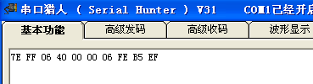(2) , if the folder for the query is empty [ indicates no valid file ] , then the serial port will return the following information directly

Error displaying query folder

(3) , if it is FLASH Query, directly to the query we give the Folder1--folder5 Can.

### The total number of folders in the current device query

|  |  |  |  |  |  |  |  |  |  |  |  |
| --- | --- | --- | --- | --- | --- | --- | --- | --- | --- | --- | --- |
| **Query folder totals** | 7E | Ff | 06 | 4F | 00 | 00 | 00 | FE | AC | Ef | Query the total number of folders for the current device |
|  | 7E | Ff | 06 | 4F | 00 | 00 | 03 | FE | AC | Ef | FOLDER1 and FOLDER2 Effective |

(1) , the user can make a query about the total number of folders for the current device. We only support the query for the number of folders under root directory. Folders containing folders are not supported. Also ask the user not to create an empty folder.

(2) , if the device has 5 a valid folder [ folder has Mp3/wav file , an empty folder, and then the total number of query folders will return a 6 Folders. Therefore, it is recommended that users do not create empty folders.

(3) , in FLASH mode, the number of query folders returns the data and Tf Card and U Not the same, for example:

#### If the data is returned: 7E FF 4F/FE AC EF

which DL = 0x03 , representing the FOLDER1 And FOLDER2 Two folders have voice files, and Folder3-folder5

There are no valid files.

# Reference circuit

Contention for the application of the chip, we provide a detailed design reference, so that you can quickly start to experience the powerful function of the chip

* Serial communication interface, baud rate default 9600 , can be modified according to customer's requirements
* of the external Io Key function can be customized according to customer demand
* External single channel power amplifier reference circuit

## Serial interface

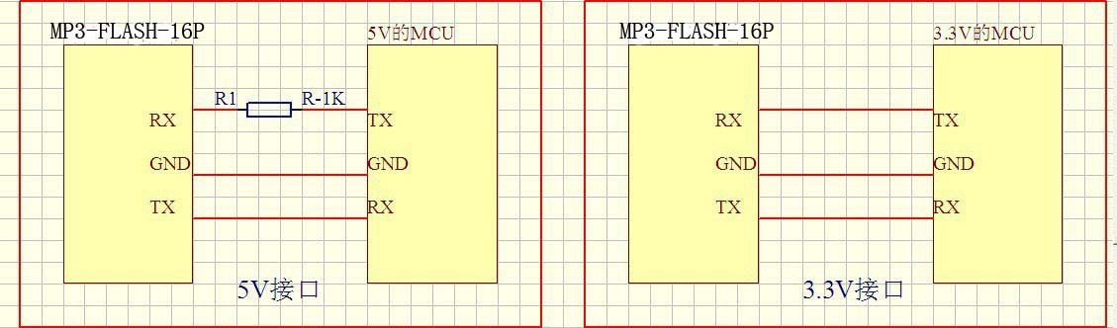

1 , the serial port of the chip is 3.3V Of Ttl level, so the default level of the interface is 3.3V .

2 , if the system is 5V . Then it is recommended that the docking interface of serial port in series 1K The resistance. This is enough to meet the general requirements,

3 , if applied to the occasion of strong electromagnetic interference, please refer to the "note" instructions.

4 , chips in 5V And 3.3V In the system are normal test, everything is normal. Are all used in a direct-attached way, and there is no string 1K

The resistance. The average chip is compatible 3.3V And 5V The level.

5 , but the user in the actual product development process, must be rigorous testing, pay attention to the level of conversion. It is strongly recommended that the user, under the conditions that can be modified, use 3.3V Of MCU , and responds to the call of environmental protection and low power consumption.

## Key interface

The chip we're using is Io Press the way to replace the AD Keyboard access, the advantage of doing so is to make full use of the MCU More and more. GPIO . Design cumbersome but not simple, we chip default configuration 6 The function of a key to assign, can be in any bad situation arbitrary control, or even can be used as with MCU Communication interface. Our key assignments 4 Different types of functions, depending on the two resistance of the selection, please contact technical support.

* One-on-one trigger playback, can be interrupted
* Trigger playback on a one-to-one level to keep cycle
* Play on a one-to-one trigger, not interrupted
* 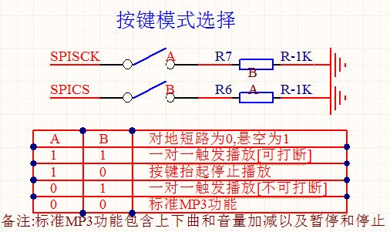Standard playback functions, such as up and down, playback pause, and so on screen printing 1 Corresponding A silk screen 2 Corresponding b[ Details PCB]

The table above is selected 10 A functional logical table of keys. When two pins are suspended for [ one-on-one triggering play can be interrupted ]

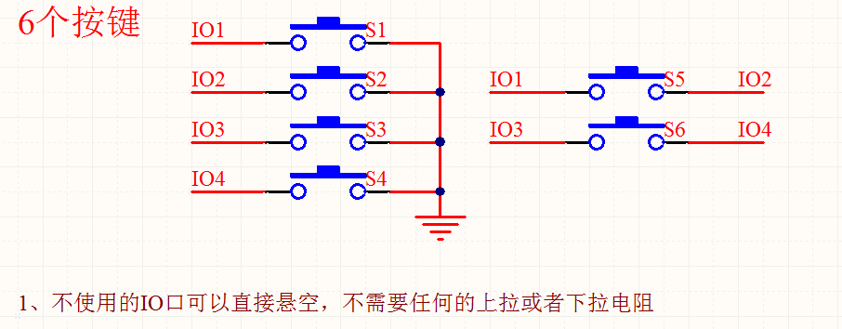

The key to stay out of the chip is s1-s4. the other S5-s6 Users need to follow the principle of the above diagram wiring

##### (1) , one-on-one trigger function [ can be interrupted ]

|  |  |  |  |  |
| --- | --- | --- | --- | --- |
| **Trigger on a one-to-one** | **Short Press** | **Long Press** | **It's not loose.** | **Press the button to lift up** |
| S1 | 1th paragraph [FOLDER1] |  |  |  |
| S2 | 2nd paragraph [FOLDER1] |  |  |  |
| S3 | 3rd paragraph [FOLDER1] |  |  |  |
| S4 | 4th paragraph [FOLDER1] |  |  |  |
| S5 | 5th paragraph [FOLDER1] |  |  |  |
| S6 | 6th paragraph [FOLDER1] |  |  |  |
| Note: This is a one-to-one trigger playback, can be interrupted [to the ground short circuit trigger 80ms effective] | | | | |

**(2)**  **, press the button to lift stop playback function**

|  |  |  |  |  |
| --- | --- | --- | --- | --- |
| **Press the button to lift up and stop** | **Short Press** | **Long Press** | **It's not loose.** | **Press the button to lift up** |
| S1 |  | 1th cycle [FOLDER1] |  | Stop it |
| S2 |  | 2nd cycle [FOLDER1] |  | Stop it |
| S3 |  | 3rd cycle [FOLDER1] |  | Stop it |
| S4 |  | 4th cycle [FOLDER1] |  | Stop it |
| S5 |  | 5th Cycle [FOLDER1] |  | Stop it |
| S6 |  | 6th cycle [FOLDER1] |  | Stop it |
| Note: This is to lift stop, long press loop play [to ground short circuit trigger 800ms effective] | | | | |

(3)  **one-on-one trigger not interrupted**

|  |  |  |  |  |
| --- | --- | --- | --- | --- |
| **Trigger does not interrupt** | **Short Press** | **Long Press** | **It's not loose.** | **Press the button to lift up** |
| S1 | 1th paragraph should not be interrupted [FOLDER1] |  |  |  |
| S2 | 2nd paragraph should not be interrupted [FOLDER1] |  |  |  |
| S3 | 3rd paragraph should not be interrupted [FOLDER1] |  |  |  |
| S4 | 4th paragraph should not be interrupted [FOLDER1] |  |  |  |
| S5 | 5th paragraph should not be interrupted [FOLDER1] |  |  |  |
| S6 | 6th paragraph should not be interrupted [FOLDER1] |  |  |  |
| Note: This is a one-to-one trigger playback, not interrupted [to ground short circuit trigger 80ms effective] | | | | |

##### (4) , standard playback function

|  |  |  |  |  |
| --- | --- | --- | --- | --- |
| **Play function key** | **Short Press** | **Long Press** | **It's not loose.** | **Press the button to lift up** |
| S1 | Next song |  | Volume + |  |
| S2 | A song. |  | Volume |  |
| S3 | Playback paused |  |  |  |
| S4 | Stop it |  |  |  |
| S5 | Volume + |  |  |  |
| S6 | Volume |  |  |  |
| Note: This is the standard MP3 feature | | | | |

* 1. **External single channel Amplifier**

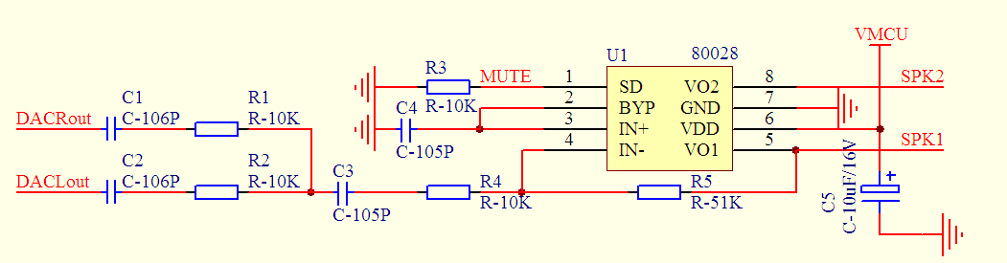

Here's the amp we're using 8002 , please refer to the specific parameters Ic Of datasheet . Applied to the general occasion enough, if the pursuit of more

High quality, please ask the customer to find the right amplifier.

* 1. **The user adjusts the volume of the amplifier**

Our chip by default is the maximum volume, if the user wants to reduce the volume, you can from the following 2 A place to modify

(1) , modify the chip Dac The output of the current limiting resistor, we default is affixed 1K resistance, the user wants to reduce the volume, can be appropriate to increase this resistance. DAC The resistance position refers to the following figure " 1 "The Red box marked

(2) , modify the amplifier magnification, we default is " 51K "The resistor, if the user wants to reduce the volume, may suitably reduce this resistance, may fix changes to 47K Or 33K . Seethesign of the red box "2" below

## Usb Update speech description

Our module can use mobile phone charging line to update voice directly, convenient and flexible. Our advantage is as follows

* Can correct the information of the downloaded speech according to the customer's request
* No software to install, direct update, no special downloader required
* No compression and damage to the sound quality to ensure a higher quality experience

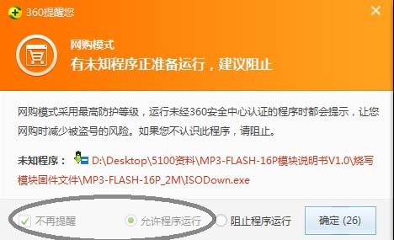1 , plug in our mobile phone charge line, called microUSB Line. The computer will eject the following interface, and then the computer's 360 Software, or antivirus software turned off, or plugged in Usb The following pop-up window is selected to allow the program to run:

2 , the computer will eject the following interface



1 , double-click the left mouse button, the computer will pop up the following interface ( 1 )

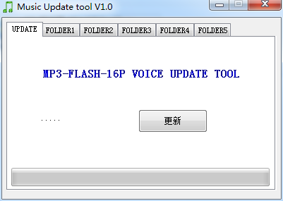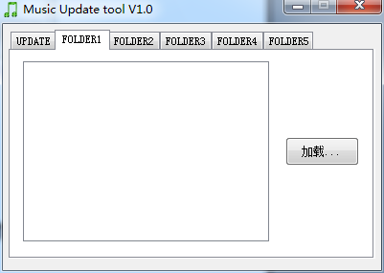

( 1 ) 2 )

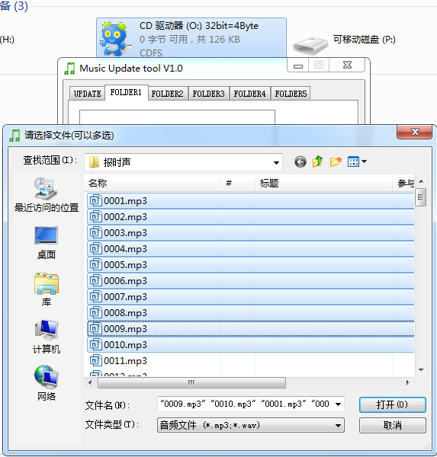2 , select the FOLDER1 folder, as shown above ( 2 and click Load, will pop up a loaded speech window, the following figure

Click the left mouse button to drag the selected, or press the keyboard Ctrl Key, one by one of the selected sound files

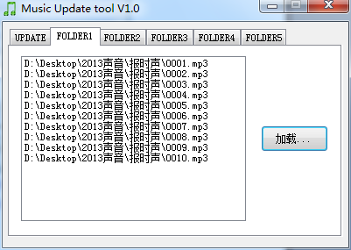3 , select the voice that needs to be loaded at this time, click "Open" to add in the software.

4 , and finally, back to " UPDATE interface, click the "Update" button, the following interface will appear

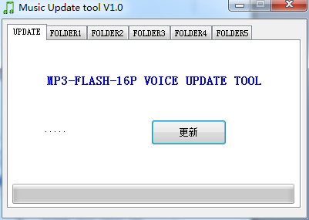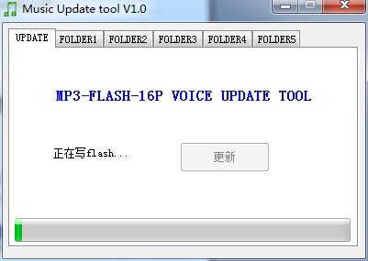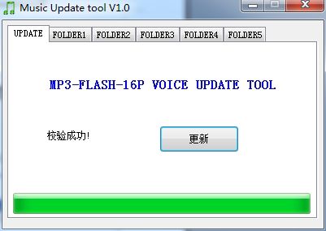

5 ,

From left to right in turn 3 window, the last window on behalf of the update completed, directly close this window, unplug Usb Line on it.

5 , the current test we have Spiflash including China State, GD , Macronix and other market volume of the largest FLASH . So FLASH There is no problem with compatibility. We've tested it. FLASH . Most greatly 16M byte [w25q128], all is no problem.

6 , because the update progress bar of our updated window is the maximum support only 8M BYTE, so use 16M bytes of FLASH , the following interface will appear, please the user friend Don't worry, this is normal

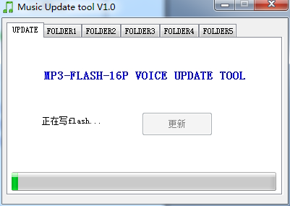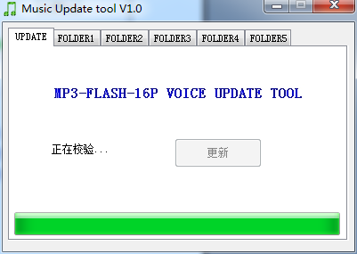Although the progress bar has not changed, but still in the more

New

7 , updated Description:

(1) , our update window is reserved for 5 Area to be updated, named Folder1--folder5. This version supports 5 Specified playback action for a zone

(2) , Folder1--folder5 This 5 Areas are not allocated space and are scalable. For example, I just use FOLDER1 , do not use the other 4 File area, then this 4 Does a file area take up space? It's not going to happen. 10 a byte , can be ignored. (3) , each FOLDER Maximum Area support 255 Segment Voice [ in the case of space permitting ] . The size of a single voice is not required. Current FLASH Maximum Support 128Mbit . Is 16M Byte of speech storage enough to satisfy most applications

(4) , if the user on the quality requirements are not high, you can choose the voice compression software, the MP3 Or Wav Files are compressed to reduce the storage space that the files occupy. In order to reflect the high quality of our products, users are not advised to use

(5) , USB The time to update the speech is based on the size of the voice file, and the greater the voice, the slower the update time.

(6) , once the speech has been updated, the previously saved speech will be deleted.

7 , notes:

(1) , our module does not need to install any software, insert the computer pop-up software is actually burned to Spiflash . Occupied 200kb of space. Very small, so users can ignore it directly.

(2) , users need to change their own Spiflash . Please request the updated firmware from our technical support.

(3) , if the computer for the first time using our module, just plugged into the computer, it will take a certain amount of time, because at this time the computer will automatically enumerate my modules, determine identity and so on operation. May need 1 Minutes or so until the update window pops up.

## User uses a blank FLASH Description

In the process of commissioning, the user will be replaced according to their own needs Flash Size to meet your needs, so you need the following three steps to complete FLASH The replacement.

* Ask us to get FLASH The update firmware
* Pass Usb interface to a blank FLASH To burn the firmware
* Pull Usb Cable, and then power on to normal use

1 , our firmware is divided into 4 section, please explain in detail below

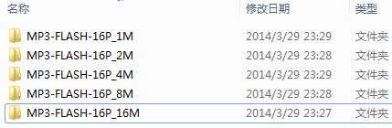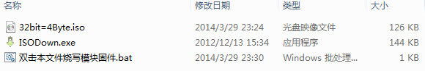

Users according to their own FLASH Size to select the updated firmware. The firmware is the same size.

the right figure is actually through " Double-click this file to burn the module firmware . Bat " This batch calls " ISDDown.exe "Software will" 32bit=4byte.iso.iso the mirrored file writes FLASH In This is open source tools, interested in the information can be consulted to understand the entire process.

2 , through Usb after inserting the computer, click " Mydown.bat , the following window will pop up

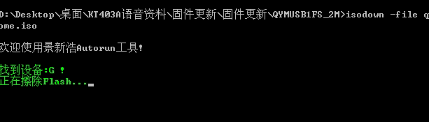

#### 3, after the completion of the update, the following interface will appear:

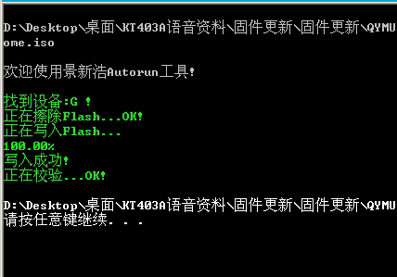

4, after the completion of the update, you can see the computer has been virtual out of a "CDROM", so that the success of the statement. Note: If any exception occurs during the update process, it is not normal and you can change the FLASH to determine the problem.

1. **Attention matters**

the use of chips , the key place to do the following description :

* of the Chip GPIO The characteristics
* Application of the Notes
* The attention of serial programming part

## GPIO The characteristics

|  |  |  |  |  |  |  |
| --- | --- | --- | --- | --- | --- | --- |
| IO Input characteristics | | | | | | |
| Symbol | Parameters | Minimum | Typical | Biggest | Unit | Test conditions |
| V IL | Low-level Input  Voltage | -0.3 | - | 0.3*vdd | V | vdd=3.3v |
| V IH | High-level Input  Voltage | 0.7VD  D | - | vdd+0.3 | V | vdd=3.3v |
| IO Output characteristics | | | | | | |
| Symbol | Parameters | Minimum | Typical | Biggest | Unit | Test conditions |
| V OL | Low-level Output  Voltage | - | - | 0.33 | V | vdd=3.3v |
| V OH | High-level Output  Voltage | 2.7 | - | - | V | vdd=3.3v |
|  |  |  |  |  |  |  |

* 1. **Points of attention in application**

1 , the external interface of the chip are 3.3V Of Ttl level, so in the design of the hardware circuit, please pay attention to the conversion of the level. In addition, in the strong interference environment, please note that some of the electromagnetic compatibility of protection measures, GPIO Using Optocoupler isolation to increase Tvs Wait a minute

2 , Adkey The key values are in accordance with the general use of the environment, if in strong sensibility or capacitive load environment, please pay attention to chip power supply, the proposed separate isolation power supply, and then with the magnetic bead and inductance on the power filter, be sure to as much as possible to ensure the stability of the input power supply and clean. If there is no guarantee, please contact us to reduce the number of keystrokes and redefine the wider voltage distribution.

3 , serial communication, in the general use of the environment, pay attention to good level conversion can be. If the environment is strongly disturbed, or the long distance RS485 Application, then please pay attention to the signal isolation, in strict accordance with industrial standards to design communication circuits. Can contact us, we provide design reference

4 , we support the lowest sampling rate for audio files 8KHZ . That means less than 8KHZ The audio file is not supported and cannot be decoded properly. Users can use audio processing software to improve the sampling rate of audio files to solve this problem.

5 , the current of the chip in the sleep state 10MA The peak current can be achieved by the size of the volume on the playback 1 A . Power consumption will be relatively large. If used in a low-power situation, please control the chip or chip power supply. This will reduce the power consumption of the chip

6 , if the user directly using our chip with the amplifier, please select the appropriate speaker. Recommended Use 4 Ohm /3w . This is the best use of the configuration. Choose the other speakers, please note the load size, as well as the power of the two parameters

7 , the chip supports MP3 , WAV Two kinds of mainstream audio formats.

8 , our chips support the 8/11.025/12/16/22.05/24/32/44.1/48khz sampling rate of audio files, these are also the vast majority of the network audio files parameters. If the user's audio file sample rate is not in this range, it is not supported playback, but can be converted through a dedicated software. Our advantage is lossless playback and high quality, so the user is less recommended to compress the audio.

## Serial operation

The operation of the serial port, see the following process, we provide a complete reference routine, for users to refer to :

* Operation Process of serial port
* Description of serial port programming reference
* Need to delay the operation of the serial port considerations

### Serial Operation Flow

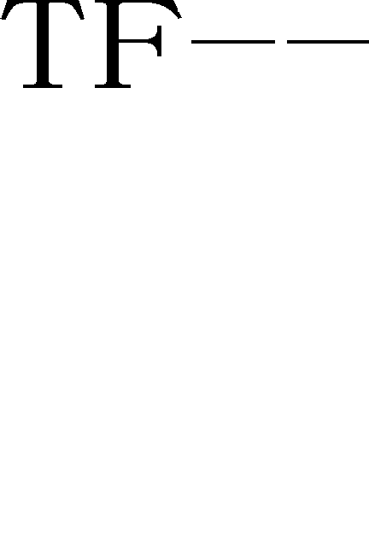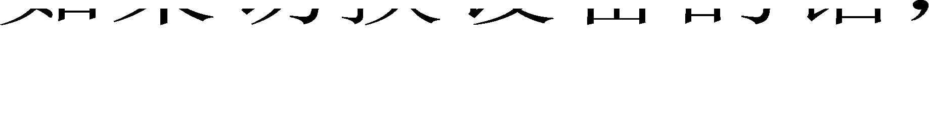

1 , we provide all the chips of the serial port part of the operation, are the same agreement, so do not worry about the different chip incompatible

2 , if the operation of the serial port, there is any do not understand, please be sure to contact us to obtain serial programming reference routines.

3 , our product updates, will also be in accordance with the current protocol version, to do backward compatibility.

### Description of serial port programming reference

#### At present, we provide the serial port programming reference code, there are two parts, the first part is our test version of the test code, the relevant serial operation is more comprehensive, the other is the basic version, just a designated track example. Please the user patiently digest

* + 1. **Serial port programming needs the attention point of appropriate delay**

1 , after the chip on the power, need to probably 1s-1.5s The time carries on the Hatsuhana the correlation operation, after initialization completes, will have the initialization related data to send out. Users can also ignore the data directly

2 , delay is required when the specified device is played 200ms Time, then send the specified track and so on related instructions.

3 , because the chip with the file system, under normal circumstances, the track is not greater than 1000 First words, the response rate is less than 50ms The tracks over 3000 After the first, the file system switching speed will be slower, the response speed in 100MS---1S Ranged between

4 , chip internal to the processing of the serial port is 10MS Processing once, so sequential instructions must be sent at intervals 20MS The delay. Otherwise, the previous instruction will be overwritten without execution.

5 , if the specified folder file name plays [0x0f directives ] , the delay must be greater than 40ms , because it takes time for the chip to lock the file. As long as the relevant instructions related to folder file name lookup, 40MS The delay is essential. If the chip is currently looking for files, serial data is too frequent, will lead to the reduction of the chip

### Important Notes for checksums

1 , contention for many users are not accustomed to the calibration of the communication methods, we have introduced a checksum with checksums without verification of a compatible way. An example is provided. If we send the combined playback instructions as follows :

|  |  |  |
| --- | --- | --- |
| **Next play [without check]** | 7E FF (EF) |  |
| **Next play [with check]** | 7E FF 06 01 00 00 00 FE FA Ef |  |

The difference between two instructions is to omit the checksum 2 Bytes. These two-frame data can be received by the chip.

2 , because many users in the use of the process, many are used without crystal oscillator MCU . In this way, we must recommend that you add a checksum to ensure the stability of the communication.

3 , if users use STM32 Or Stc Wait a minute MCU , and is the external crystal oscillator, can be appropriate to dispense with the checksum. Because without the crystal oscillator MCU , the clock is relatively not so accurate, so there will be errors in the serial port, once the error is too large, will lead to communication errors. Please the user friend discretion.

### MCU Selection of crystal oscillator

#### 1 , in principle, we recommend that users use 11.0592MHZ Or the crystal oscillator of the phase multiple. This allows the serial port to produce

9600 The baud rate will be more accurate. Our chip serial error is allowed in 3% within the

2 , if the user is 12M When the crystal oscillator. The first thing to do is to make the following judgments

(1) , see what is MCU , 51 Or PIC , STM32 And so on, basically all with the baud rate generator, so produce

9600 The baud rate is basically no pressure.

(2) , see MCU Whether it is a hardware serial port, if it is Io Analog serial port, it is strongly recommended that users use 11.0592

of Crystal Oscillator

(3) , standards of Wuyi , such as: stc89c52 Or At89c52 And so on are the use of timers to generate baud rate, after a simple calculation can be calculated, 12M Crystals do 9600 The baud rate error is 0.16% , the normal operation is not any problem, but still need the user to conduct a comprehensive test

1. **Disclaimer**

##### Develop a knowledge of preparation

The company's products will provide as comprehensive as possible the development of templates, drivers and their application documentation to facilitate the use of users but also require users to familiarize themselves with the design of products used in the hardware platform and related C Knowledge of the language

##### Emi And Emc

The company's chip mechanical structure determines its Emi The performance must be different from the integrated circuit design. The company's chip chip Emi

to meet the vast majority of applications, users have special requirements, must consult with us in advance .

The company's chip Emc The performance is closely related to the design of the user backplane, especially the power circuit, I/O Isolation, reset circuit, the user in the design of the backplane must fully consider the above factors. We will strive to improve the company's chip electromagnetic compatibility characteristics, but not the final application of user products Emc performance provides any guarantee .

##### Power to modify a document

The company can retain any time without prior notice of the company's chip products related to the modification of the document power

##### Esd Electrostatic release Point Protection

Part of the company's products built-in components Esd Protection circuit, but in the use of harsh environment, it is still recommended that users in the design of the backplane to provide Esd Protection measures, especially the power supply with Io Designed to ensure stable operation of the products, installation of the company's products to ensure safety, please first accumulate in the body of electrostatic release, such as wearing a reliable grounding of the electrostatic ring, touch access to the Earth's pipe, etc.

# Reference routines

/******************************************************************************

* Realization function: Realize the chip on the power to specify the first and second play, the basic program for users to test

- Day Period: 2013-05-06

- Operating Environment: STC crystal oscillator: 11.0592M baud rate : 9600

* Preparation Note: In Pu-Zhong Technology's 51 Debug on Development Board OK---stc89c516rd+

The test program must be a chip or chip solution with devices online, such as U disk, TF Card, FLASH

******************************************************************************/

#include "REG52.h"

#define Comm_baud_rate 9600// serial port baud rate

#define Osc_freq 11059200// operation Crystal Oscillator: 11.05926MHZ static int8u send_buf[10] = {0};

void Delay_ms (int32u z)

{

Int32u x=0, y=0;

for (x=110; x>0; x--)

for (y=z; y>0;y--);

}

/******************************************************************************

* Function Description: Serial port 1 Class
* Note : Set to 9600 Baud rate

/void Serial_init (void)

{

Tmod = 0x20;// Set up T1 For the baud rate generator

Scon = 0x50;//0101,0000 8 bit data bits , No parity

PCON = 0x00

th1=256-(OSC_FREQ/COMM_BAUD_RATE/32/12); set to 9600 Baud rate

tl1=256-(OSC_FREQ/COMM_BAUD_RATE/32/12);

|  |  |  |
| --- | --- | --- |
| TR1 | = 1; | // Timer 1 Open it |
| REN | = 1; | // Serial Port 1 Receive to enable |
| Es | = 1; | // Serial Port 1 Interrupt Enable to |

}

void Uart_putbyte (int8u ch)

{

sbuf= ch;

while (! TI) {;} TI = 0;

}

/******************************************************************************

* function Description: The serial port sends out the command [ including controls and Queries ]
* Parameter description: CMD: to indicate control instructions, consult the instruction list, as well as the related instructions for the query.

Feedback: Whether you need to answer [0: no answer required, 1: answer required ]

Data: parameters to transfer

/void Sendcmd (int8u len)

{

int8u i = 0;

Uart_putbyte (0x7E); Start For (i=0 i<len; i++)// Data

{

Uart_putbyte (Send_buf[i]);

}

Uart_putbyte (0xEF);// End

}

/******************************************************************************

* Function Description: Sum checksum --- The user can also omit this checksum, see 5.3.4 The description
* And check the following ideas:

Send the instructions to remove the start and end. Will the middle of the 6 Byte to add, and finally the inverse code. The receiving side will receive a frame of data, remove the start and end. The intermediate data is added together with the received checksum byte. Just for 0. This means that the data received is completely correct.

/void Dosum (int8u *str, int8u len)

{

int16u xorsum = 0; int8u i;

for (i=0; i<len; i++)

{

xorsum= xorsum + str[i];

}

Xorsum= 0-xorsum;

* (str+i) = (int8u) (Xorsum >>8);

* (str+i+1) = (int8u) (Xorsum & 0X00FF);

}

void Uart_sendcmd (int8u CMD, int8u feedback, int16u dat)

{

Send_buf[0] = 0xff;// reserved byte send_buf[1] = 0x06;// length

SEND_BUF[2] = cmd;// control instruction send_buf[3] = feedback;// need feedback

SEND_BUF[4] = (int8u) (DAT >> 8);//datah send_buf[5] = (int8u) (DAT); Datal dosum (&send_buf[0],6); Checksum Sendcmd (8);// Send this frame data

}

void Main ()

{

serial_init ()// initialization settings for serial registers

uart_sendcmd (0x03, 0, 0x01); play the first song Delay_ms (1000); Delay probably 6S

uart_sendcmd (0x03, 0, 0x02); Play second song Delay_ms (1000); Delay probably 6S

uart_sendcmd (0x03, 0, 0x04); play the fourth song While (1);

}

# Pc Example of debugging instructions for Port serial port

The user can test the chip through the serial port software of the computer. Our chip serial port is Ttl level, please note that the level conversion

* Control instructions
* Query parameter directives

## Control instructions

|  |  |  |  |
| --- | --- | --- | --- |
| **Serial debugging assistant for testing** | **Commands sent [with checksums]** | **Commands sent [without checksums]** | **Note** |
| **[Next song]** | 7E FF 06 01 00 00 00 FE FA Ef | 7E FF (EF) |  |
| **[Previous song]** | 7E FF 06 02 00 00 00 FE F9 Ef | 7E FF/EF |  |
| **[Specify tracks]** | 7E FF 06 03 00 00 01 FE F7 Ef | 7E FF (EF) | Specify first play |
| 7E FF 06 03 00 00 02 FE F6 Ef | 7E FF (EF) | Specify second head |
| 7E FF 0A FE EE Ef | 7E FF 0A EF | Designation 10th |
| **Volume Plus** | 7E FF 06 04 00 00 00 FE F7 Ef | 7E FF/EF |  |
| **Volume reduction** | 7E FF 06 05 00 00 00 FE F6 Ef | 7E FF/EF |  |
| **[Specify volume]** | 7E FF 1E FE D7 Ef | 7E FF 1E EF | Specify a volume level of 30 |
| **[Assign EQ]** | 7E FF 06 07 00 00 01 FE F3 Ef | 7E FF/EF | Keep |
| **[Loop play track]** | 7E FF 06 08 00 00 01 FE F2 Ef | 7E FF EF | Loop play the first song |
| 7E FF 06 08 00 00 02 FE F1 Ef | 7E FF/EF | Loop second Song |
| 7E FF 0A FE E9 Ef | 7E FF 0A EF | Loop to play the tenth song |
| 7E FF 06 08 00 01 01 FE F1 Ef | 7E FF-EF | Loop the first song of FLASH's FOLDER1 |
| 7E FF 06 08 00 02 01 FE F0 Ef | 7E FF EF | Loop the first song of FLASH's FOLDER2 |
|  |  |  |  |
| **[Specify Playback device]** | 7E FF 06 09 00 00 01 FE F1 Ef | 7E FF EF | Specify Playback Udisk |
| 7E FF 06 09 00 00 02 FE F0 Ef | 7E FF (EF) | Specify play TF |
| 7E FF 06 09 00 00 03 FE EF Ef | 7E FF/EF | Specify to play FLASH |
|  |  |  |  |
| **[Enter sleep mode]** | 7E FF 0A 00 00 00 FE F1 Ef | 7E FF more 0A EF |  |
| **[Wake up Sleep]** | 7E FF 0B 00 00 00 FE F0 Ef | 7E FF more 0B EF |  |
| **[Chip Reset]** | 7E FF 0C 00 00 00 FE EF Ef | 7E FF more 0C EF |  |
| **Play** | 7E FF 0D 00 00 00 FE EE Ef | 7E FF more 0D EF |  |
| **Suspended** | 7E FF 0E 00 00 00 FE ED Ef | 7E FF more 0E EF |  |
| **[Specify folder file name]** | 7E FF 0F 00 01 01 FE EA Ef | 7E FF (0F) EF | "01" folder, Track is "001" |
|  | 7E FF 0F 00 01 02 FE E9 Ef | 7E FF (0F) EF | "01" folder, Track is "002" |

|  |  |  |  |
| --- | --- | --- | --- |
| **Stop playing** | 7E FF 06 16 00 00 00 FE E5 Ef | 7E FF/EF | Stop software decoding |
| **Specify a folder loop to play** | 7E FF 06 17 00 02 00 FE E2 Ef | 7E FF EF | Specify 02 folder loop playback |
|  | 7E FF 06 17 00 01 00 FE E3 Ef | 7E FF ' EF | Specify 01 folder loop playback |
| **Random playback** | 7E FF 06 18 00 00 00 FE E3 Ef | 7E FF/EF | Random playback |
| **Single Loop playback** | 7E FF 06 19 00 00 00 FE E2 Ef | 7E FF/EF | Single Loop playback Open |
|  | 7E FF 06 19 00 00 01 FE E1 Ef | 7E FF ' EF | Single Loop playback off |
| **Play with Volume** | 7E FF 01 1E FE BA Ef | 7E FF 1E EF | Level 30, play the 1th song. |
|  | 7E FF 01 0F FE C9 Ef | 7E FF 0F EF | Level 15, play the 1th song. |
|  | 7E FF 02 0F FE C8 Ef | 7E FF 0F EF | Level 15, play the 2nd song. |

* 1. **Query parameter directives**

|  |  |  |  |
| --- | --- | --- | --- |
| **Serial debugging assistant for testing** | **Commands sent [with checksums]** | **Commands sent [without checksums]** | **Note** |
| **Query Current state** | 7E FF 06 42 00 00 00 FE B9 Ef | 7E FF/EF |  |
| **[Query Volume]** | 7E FF 06 43 00 00 00 FE B8 Ef | 7E FF EF |  |
| **[Query Current EQ]** | 7E FF 06 44 00 00 00 FE B7 Ef | 7E FF EF |  |
| **U Disk Total File number** | 7E FF 06 47 00 00 00 FE B4 Ef | 7E FF EF | The total number of files for the current device |
| **Total number of TF files** | 7E FF 06 48 00 00 00 FE B3 Ef | 7E FF EF |  |
| **FLASH Total File Number** | 7E FF 06 49 00 00 00 FE B2 Ef | 7E FF EF |  |
| **U disk Current Track** | 7E FF 4 B 00 00 00 FE B0 Ef | 7E FF 4 EF | Currently playing tracks |
| **TF Current Track** | 7E FF 4C 00 00 00 FE AF Ef | 7E FF more 4C EF |  |
| **FLASH current Folder track pointer** | 7E FF 4D 00 00 00 FE AE Ef | 7E FF more 4D EF |  |
| **Specify folder track totals query** | 7E FF 4E 00 00 01 FE AC Ef | 7E FF (4E) EF |  |
| **Query tf/u Disk Total folder number** | 7E FF 4F 00 00 00 FE AC Ef | 7E FF more 4F EF | Only TF cards and USB drives are supported |